BIG DATA LAB

Name:S.L.A.Laisha

USN:1NT19IS147

SEC:C1

Date: 05-04-2022

Tasks To complete

To start with hadoop

>hadoop version

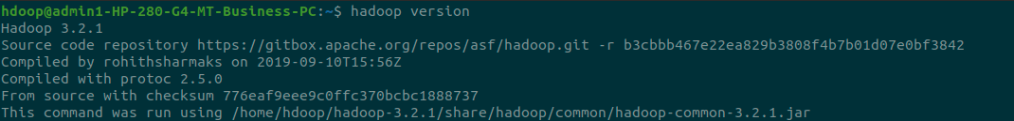

>start-dfs.sh

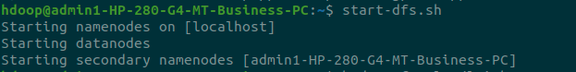

1. Create a directory named by your name

>hadoop fs -mkdir /laisha

>hadoop fs -ls /

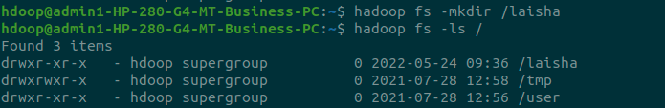

2. Add two empty files into it

>hadoop fs -touchz /laisha/one.txt

>hadoop fs -touchz /laisha/two.txt



3. List all the files in the directory that you have created

>hadoop fs -ls /laisha

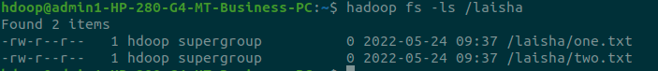

4. Create one more directory by your usn and put that inside the directory of your name

>hadoop fs -mkdir /laisha/1NT19IS147

>hadoop fs -ls /laisha

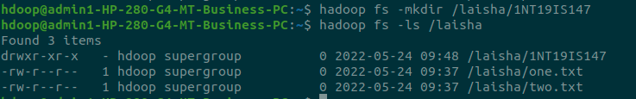

5. Create a file in your local system by the name_usn.txt and add the contents as "Syntax to list Is command is hadoop fs -Is "

>cat > laisha_1NT19IS147.txt

>"Syntax to list ls command is hadoop fs -ls"

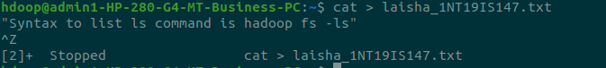

Tasks To complete contd...

►Put the file usn_name.txt in your hdfs directory called usn

>hadoop fs -touchz /laisha/1NT19IS147/1NT19IS147_laisha.txt

>hadoop fs -ls /laisha/1NT19IS147



➤Put empty file of hdfs into the local file system

>hadoop fs -copyToLocal /laisha/1NT19IS147/1NT19IS147_laisha.txt

>ls



►Use mv command to move files from local file system and hdfs file system

>hadoop fs -mv /laisha/two.txt /laisha/1NT19IS147

>hadoop fs -ls /laisha/1NT19IS147

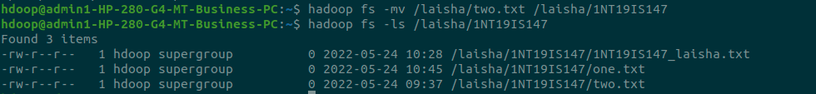

▸ Experiment of cp command

>hadoop fs -cp /laisha/one.txt /laisha/1NT19IS147

>hadoop fs -ls /laisha/1NT19IS147

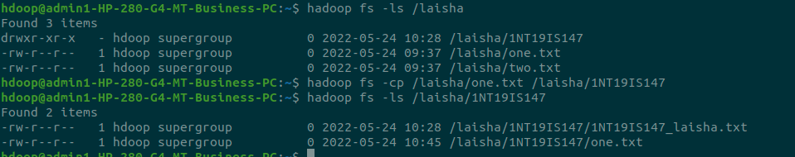

► Display the total size of all the files in name directory

>hadoop fs -du /laisha

>hadoop fs -du -s /laisha

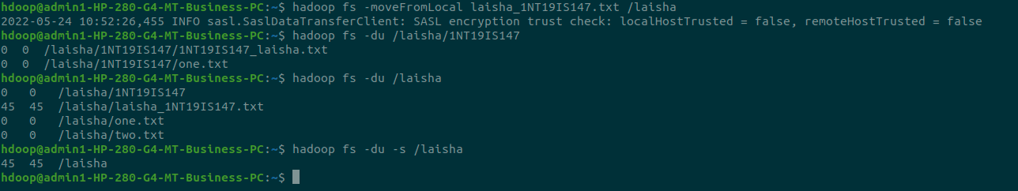

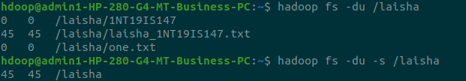

► Display each file size in usn directory Use stat command on name and usn directories

>hadoop fs -du /laisha/1NT19IS147

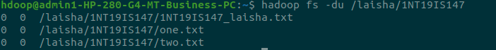

➤ Illustrate the use of append command

cat > one.txt

Hello

^Z

[4]+ Stopped cat > one.txt

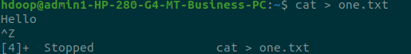

>hadoop fs -appendToFile one.txt /laisha/1NT19IS147/two.txt

>hadoop fs -cat /laisha/1NT19IS147/two.txt

